Modern and Postmodern Thought
Semester 6, G 3
Prof. Nachit
Course N 3: Modernism in Arts
- Modern art
As stated in the previous class, modernity was a holistic project involving all sectors of western society and culture. The driving force behind this dynamic was the desire to break with the past and create new paradigms that speak for the contemporary individual. Artists were at the forefront of this deep mutation. Bradbury and McFarlane (1976) describe this complex and extraordinary affair as follows: “an extraordinary compound of the futurist and the nihilistic, the revolutionary and the conservative, the naturalistic and the symbolic, the romantic and the classical. It was the celebration of a technological age and condemnation of it; an excited acceptance of the belief that the old regimes of culture were over, and a deep despairing in the face of that fear; a mixture of convictions that the new forms escapes from historicism and the pressures of the time with convictions that they were precisely the living expressions of these things” (p. 46).
Modern artists at the beginning of the twentieth century were rebellious against their society and adopted a radical approach to change and revitalize the cultural norms and perceptions. Artists in the period between 1900 and 1930 rejected their culture, deemed corrupt, lethargic and artificial and started exploring other forms of expression that catch the innate, primitive and authentic feelings of the modern Man. They created new techniques, addressed new issues that were considered taboo or not politically correct by the conservative society.
Modernism in art was also associated with nihilism and a rejection of all the certainties and truths of the past. Such artists criticized the religious and moral principles of their society that often relied on arbitrariness and conformity. These artists believed that such an order suffocates any attempt to create or to express human freedom. At the same time modern art was re-inventing itself by breaking with the old. Doubt and scepticism were the fundamentals of this new art and by so doing these artists were expressing in their own way what was happening in other fields such as the scientific discoveries. Einstein’s theory of relativity, Freud’s discoveries in psychology and Nietzsche’s pleas for anarchy and disorder were shaping the thoughts and works of such artists. David Harvey puts this as follows:
“The shift in modernism’s tone also stemmed from the need to confront head-on the sense of anarchy, disorder, and despair that Nietzsche had sown at a time of astonishing agitation, restlessness, and instability in political-economic life- an instability which the anarchist movement of the late nineteenth century grappled with and contributed to in important ways. The articulation of erotic psychological and irrational needs (of the sort that Freud identified) added another dimension to the confusion. This particular surge of modernism, therefore, had to recognize the impossibility of representing the world in a single language. Understanding had to be constructed through the exploration of multiple perspectives. Modernism, in short, took on multiple perspectivism and relativism as its epistemology for revealing what it still took to be the true nature of a unified though complex, underlying reality” (p. 30).
Driven by such new Ways of looking (John Berger), modern artists at the beginning of the twentieth century questioned academic arts and embarked on other forms that allowed a higher degree of freedom. Many new trends emerged in this period such as fauvism, expressionism, cubism, Dadaism, surrealism with iconic artists like Pablo Picasso, Salvador Dali, Joan Miro, etc. All these new forms deliberately abandoned the old established mimetic tradition that the ancient Greeks invented to regulate artistic creativity and was mechanically followed by European artists for centuries. The modern artist was no longer motivated by imitating nature and people; his main intention was to express new subjectivities. Each artistic work was intended to be judged as self-sufficient with its own internal laws and language without expecting formal critics to assess it according to what academia or conventions believed Fine art should resemble. In this sense modern art was extremely revolutionary and subversive not only in matters of content but form as well.
“Modernism, from its very beginning, therefore, became preoccupied with finding some special mode of representation of eternal truths. Individual achievement depended upon innovation in language and in modes of representation, with the result that the modernist work observes, ‘often wilfully reveals its own reality as a construction or an artifice’ thereby transforming much of art into a ‘self-referential construct rather than a mirror of society’”(Harvey, p. 20-21).
Modern artists celebrated freedom as their main concern and the pursuit of freedom drove them to embrace primitive cultures and abandon the stylistic refinement of bourgeois society. Primitivism allowed them to discover the truth that social conventions rendered impossible to attain. Thus taboo subjects, sexuality, dreams and fantasies become the main field of representation. Modern art was at heart more than a rebellion against society but a negation of all the principles on which the Judeo-Christian civilization was founded. Modernists were actually more in line with Nietzsche’s celebration of the festive, the degenerate, and the primitive that Dionysius symbolized in Greek mythology.
Ironically modernists were more concerned with the city than with the countryside. One could wonder why celebrating the primitive urges and drives in the city rather than in the countryside. Modernists indeed adopted a different attitude than the romantics who believed that nature symbolized the true and pure essence of Man. For the modernists, the city meant the new centre of art, science and technology. Their works captured the inner and cultural transformations taking place in the mind and surrounding of the modern Man.
- The Modern city
Just like artists, architects were the pioneers of modernity. They shaped the new urban landscape by creating new architectural forms and designs. The city became the laboratory where new definitions of housing, mapping, and urban planning took place. These modern architects wanted to create a new world that satisfies the needs and expectations of the modern era. To do so, they had to destroy or abandon the old designs and structures of the past, the traditional, organic and often impoverished neighbourhoods. The modern city was now conceived according to new expectations such as functionality, the easy circulation of people and goods, the great primacy of the automobile and satisfying the massive housing needs of the new city dwellers who came from the countryside. In The City of Tomorrow, Le Corbusier states that “People tax me very readily with being a revolutionary...the equilibrium they try so hard to maintain is for vital reasons purely ephemeral: it is a balance which has to be perpetually re-established”.
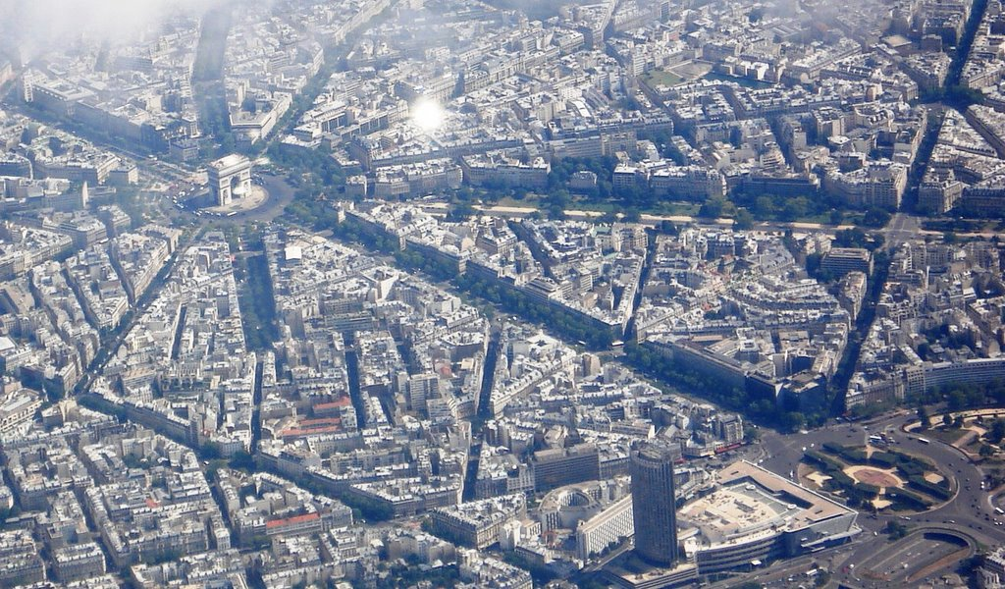
The bird eye view of Paris shows how the modern city was seen as a scientific field where minute calculations and geometric considerations where taken into account before the design of the city. The picture also demonstrates the great sense of balance and symmetry that planners followed in mapping the contours of the city. The modern city has become an open space for economic progress, social mobility and cultural energy. The modern city was thus the tangible dimension of change and development.
The modern city also expressed the downside of modernity. This could be seen in the way ideology was transcribed to the urban fabric. Communist regimes invented cities for the proletariat where houses looked like an ‘iron cage’ or to use Le Corbusier’s term “a machine for living”. These cities lacked any aesthetic or human touch. Their primary concern was to provide the working class and the new immigrants with shelter regardless of people’s culture and roots. The early signs of failure in the modernist project were revealed in the over crowdedness of cities, pollution, over congestion, crime, loose social relations, among other.

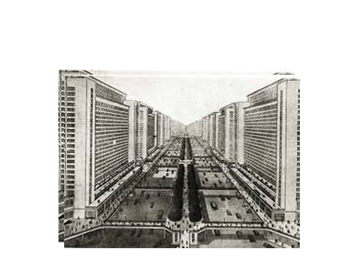

Conclusion
Modernity shaped all aspects of western society and culture. Artists were the forerunners of this deep mutation that was initially expected to liberate Man from the shackles of tradition and lethargy. But modernity would quickly lose its optimistic and humanistic objectives and become itself a source of dehumanisation and disillusionment.
The next chapter will consider this aspect of modernity and focus on the Grand Narratives of the twentieth century.
The slides attached to this chapter are intended to give you some visual illustrations of modern art and architecture.
You are expected to do more research on the issue I tackled in this chapter. My course is but an introduction to a huge topic.

